**Digital Signature Standard (DSS)**

* signature is a way of authenticating the data coming from a trusted individual. Similarly, [digital signature](https://www.geeksforgeeks.org/digital-signatures-certificates/) is a way of authenticating a digital data coming from a trusted source.
* **Digital Signature Standard (DSS)** is a Federal Information Processing Standard(FIPS) which defines algorithms that are used to generate digital signatures with the help of [Secure Hash Algorithm(SHA)](https://www.geeksforgeeks.org/sha-1-hash-in-java/) for the authentication of electronic documents.
* DSS only provides the digital signature function and does not include any encryption or key exchanging methods.

**Diagram:**

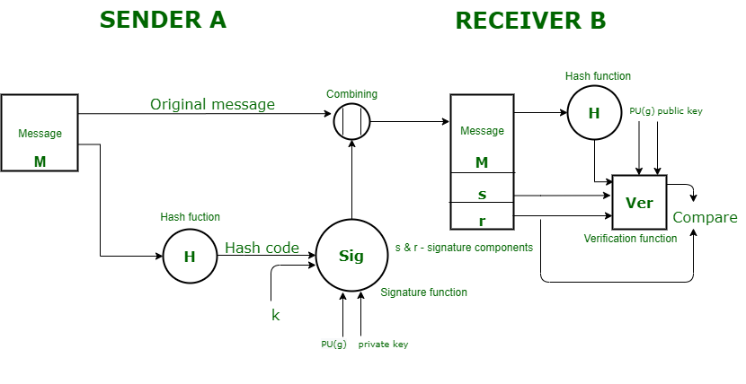

**Steps in the DSS Approach**

**Sender Side:**

1. **Hash Code Generation**:  
   Generate a hash code from the message using a Secure Hash Algorithm (SHA).
2. **Input to Signature Function**:  
   Provide the following inputs to the signature function:
   * Hash code of the message.
   * Random number kk generated for the signature.
   * Sender's private key PR(a)PR(a).
   * Global public key PU(g)PU(g) (shared set of parameters).
3. **Generate Signature**:  
   The signature function generates two components: ss and rr.
4. **Send Data**:  
   Concatenate the original message with the signature (s,rs, r) and send it to the receiver.

**Receiver Side:**

1. **Hash Code Regeneration**:  
   Compute the hash code from the received message using the same hash algorithm.
2. **Input to Verification Function**:  
   Provide the following inputs to the verification function:
   * Regenerated hash code.
   * Signature components ss and rr.
   * Sender's public key.
   * Global public key PU(g)PU(g).
3. **Verification**:  
   The verification function processes the inputs and generates an output.
4. **Comparison**:  
   Compare the output of the verification function with the received signature component rr.
   * If they match, the signature is valid, and the sender is authenticated.
   * If they do not match, the message or signature may be compromised.

**Challenges of Digital Signature Standard (DSS)**

1. **Complexity:** Setting up and managing digital signature systems can be complicated.
2. **Technology Dependence:** Requires reliable technology and internet access.
3. **Security Risks:** Vulnerable to hacking and digital fraud if not properly secured.
4. **Compatibility:** May not be compatible with all systems and software.
5. **User Adoption:** Requires users to understand and trust digital signature processes.

**Advantages of Digital Signature Standard (DSS)**

1. **Security:** Ensures the authenticity and integrity of digital documents.
2. **Non-repudiation:** Prevents senders from denying they signed a document.
3. **Efficiency:** Speeds up document processing by eliminating the need for physical signatures.
4. **Cost Savings:** Reduces costs associated with printing, mailing, and storing paper documents.
5. **Legal Validity:** Provides legal recognition and acceptance in many countries.